**OK Farms:**

Located in Elma, MB along the Whitemouth River OK farms have 3,200 hens and recently transitioned to a free-run operation. They grow all their own corn for feed and use the manure produced on farm.

**Egg production in Manitoba**

* The egg industry in Manitoba includes production and processing.
* There were roughly 2.6 million egg-laying hens and 2.9 million egg-type pullets in Manitoba in 2021.
* An egg layer farm in Manitoba typically houses 15,000 hens that lay about 380,000 dozen eggs per year.
* Egg production in Manitoba generated [$157 million](https://www.gov.mb.ca/agriculture/markets-and-statistics/financial-statistics/pubs/farm-cash-receipts-2022.pdf)in farm cash receipts in 2022, worth 20.04 per cent of total livestock farm cash receipts.
* Manitoba has seen significant growth in egg production in recent years, with about 2.7 million laying hens and 6.6 million dozen eggs sold in 2021.
* Manitoba produces 10 per cent of Canada’s eggs, with provincial layer allocations controlled through a national supply-managed marketing system.

**Laying hen housing environments in Manitoba:**

Scan the QR code for information, videos, and photos on the type of  
layer hen housing in Manitoba!

**Layer Hen Manure Management:**

Layer hen manure is an excellent nutrient resource for crops and forages, however if mis handled can pose environmental burdens for air and water quality. Proper manure management can greatly influence the amount of ammonia emissions and other losses to the environment (runoff). Managing livestock manure can be challenging due to not all animals produce the same quantity or quality of manure, diets and metabolism rates between livestock and bedding material type are a few of the causes of differences between the types of manure. Table 1 presents nutrient content for solid layer, beef and dairy manure. Poultry layer manure has a much higher nutrient content compared to pig, beef or dairy manure having approximately 4x the amount of total nitrogen and phosphorus (Tables 1 & 2).

**Table 1:** Mean for total N, ammonium, organic N, P, K, S, and available N:P205 ratios for solid layer, beef, and dairy manures (Adapted from Properties of Manure, Manitoba Agriculture 2015)

|  |  |  |  |  |  |  |  |  |
| --- | --- | --- | --- | --- | --- | --- | --- | --- |
| Solid Manure | TKN | NH4-N | Org N | P | K | S | DM % | Avail N: P205 |
| lb / ton | | | | | | | |
| Layer | 46.4 | 27.1 | 19.3 | 17.1 | 14.6 | 3.7 | 35.1 | 0.9 |
| Beef | 10.6 | 1.5 | 9 | 2.0 | 10.5 | 1.8 | 26.1 | 1 |
| Dairy | 11.5 | 2.3 | 9.2 | 3.2 | 9 |  | 26.3 | 0.8 |



**Scan the QR code to learn more about the factors that affect manure composition, properties of manure, how to properly sample manure for analysis (Properties of Manure, Manitoba Agriculture 2015).**

**Free Run housing Manure Collection:**

In Free Run housing systems hens have access to roam freely inside the entire barn. Some operations have slotted floors for the manure to fall through and collect beneath others have solid floors with wood shavings or straw, which may be collected multiple times a year or annually.

**Other Laying Hen Housing Operations:**

Most newer operations in Manitoba are dry manure operations that use manure belts or high-rise systems. Some older or mixed livestock operations will have liquid manure collection and storage systems (Poultry Producer Oct 2021, Mississippi State University Extension Service).

**Table 2:** Comparison of manure belt and high-rise hen layer dry manure systems (Poultry Producer Oct 2021, Mississippi State University Extension Service).

|  |  |
| --- | --- |
| Manure Belt System | High-Rise System |
| Manure drops onto belt beneath cage row and is transferred end of the house and outside for removal for storage or composting. | Manure drops / falls beneath the cages on to dropping boards that are cleaned 4-6x a day or into storage below the cages (can be stored for up to 1 year). |
| Manure is dried while carried along on manure belt | Manure drying is done via ventilation air passing through the hen and cage area and directed to flow over manure. |
| Generally better indoor air quality ( NH3) | Directed flow of air over manure keeps most of the NH3 from reaching the hens |
| 50% higher installation costs and Less labour intensive, but belt maintenance is crucial |  |

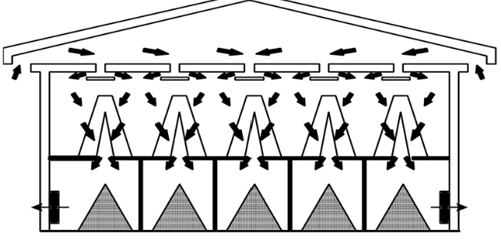

**Figure 1:** Schematic representation of high-rise (a) and manure belt (b) layer houses (Poultry Producer Oct 2021, Mississippi State University Extension Service).

**How does manure collection differ between OK farms Operation and other styles of housing units?**

**How and when does OK Farms apply their manure? Do they compost first?**

**Being located along a surface watercourse what special considerations must be made for manure storage?**

**(Scan for clues)**